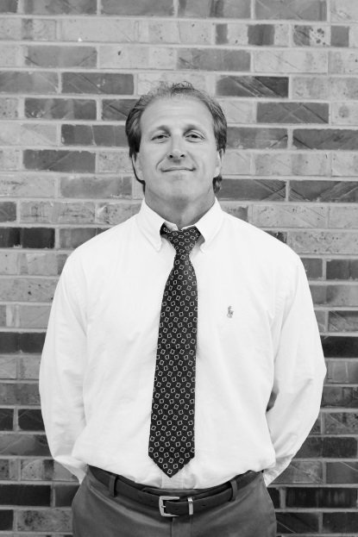
Superintendent
Kelly Lusk
klusk@farwellschools.org
806-481-3371 Extension 1011

